**Error Screenshots**

1. **Pre-Orders Screen >> Order Digitalization Page(Rx is Not Displaying)**

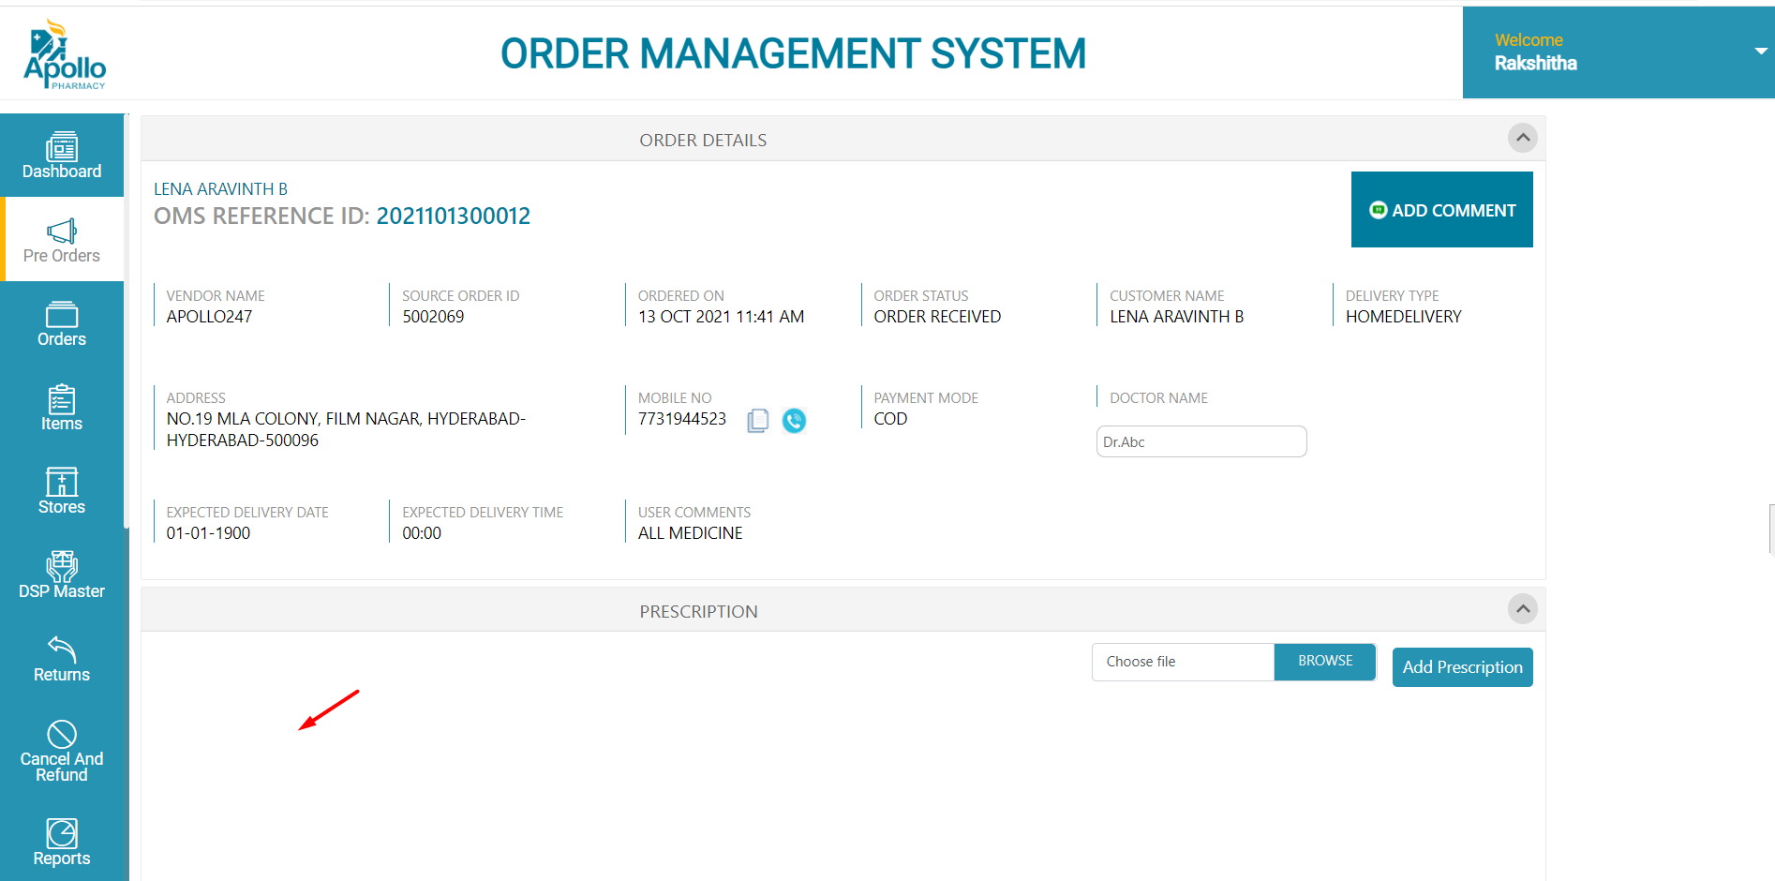

When a Cx is placing the Non-Cart Order in Order Digitalization page, “**Rx**” is not displaying.

1. **Order Digitalization & Verification Page(Rx Header is Not Displaying)**

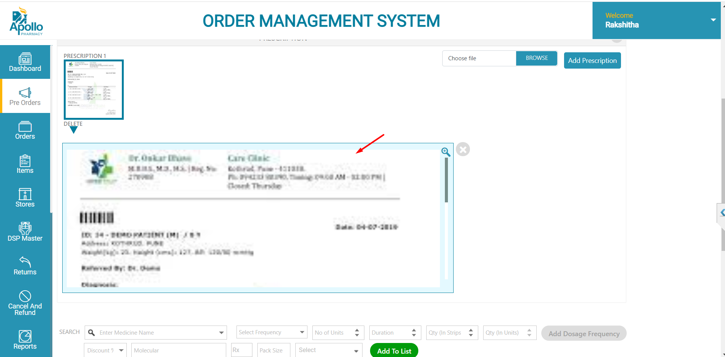

In order verification & digitalization pages “**Header**” part is missing in the Rx.

1. **Returns Screen(DSP is not allocated)**

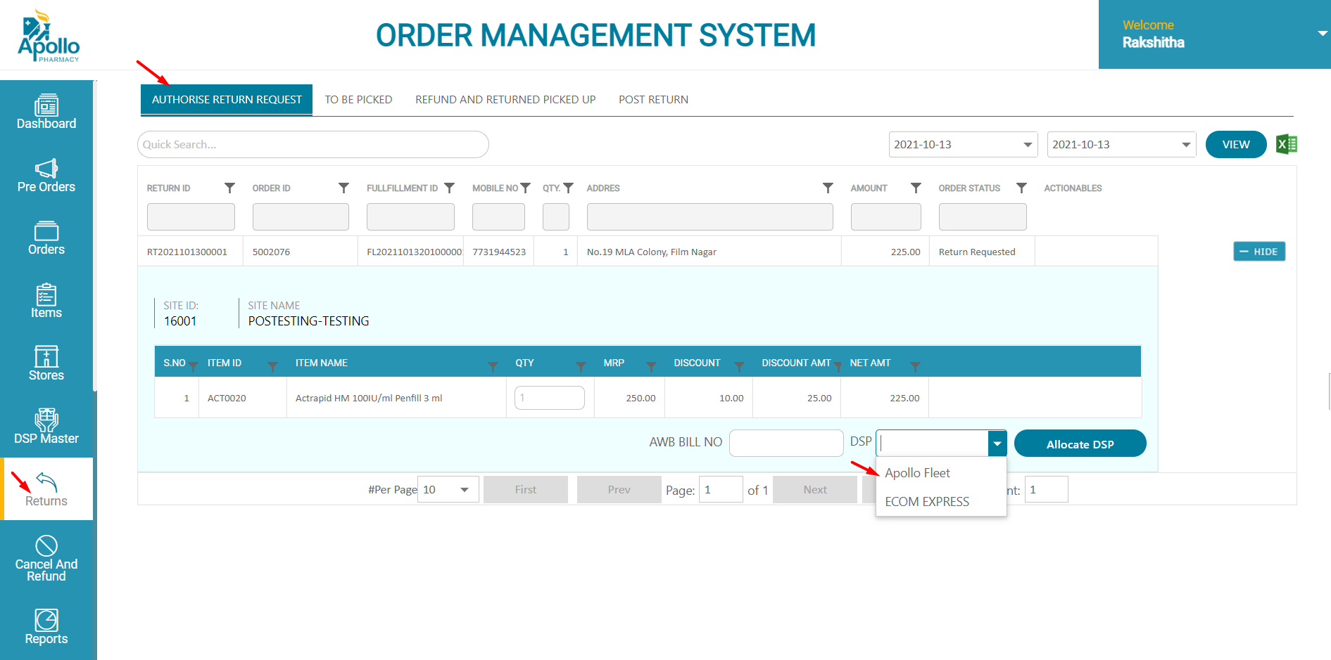

In Returns Screen >> Authorise Return Request tab, select the “**DSP**”.

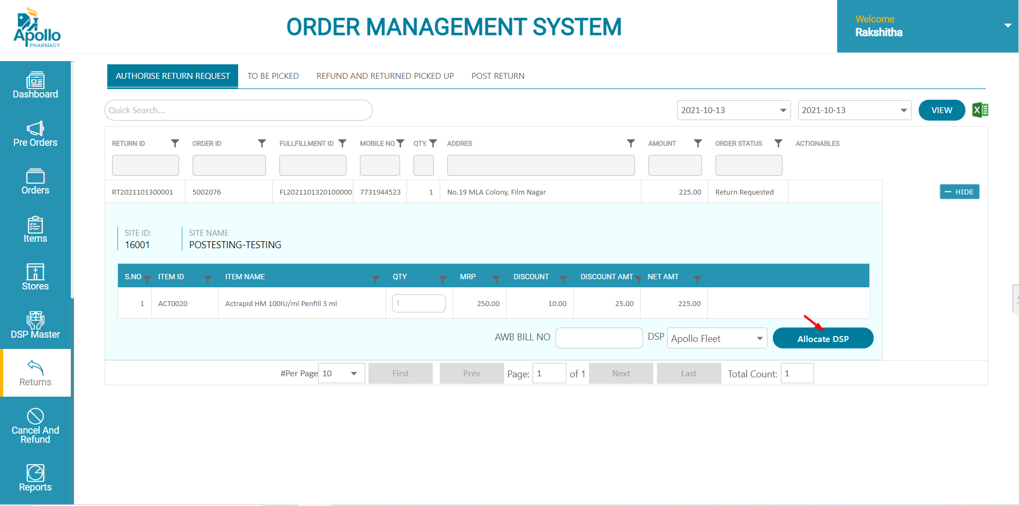

Click on “**Allocate** **DSP**” button.



DSP is Not getting Allocated.

